Design Pattern - Abstract Factory Pattern

Abstract Factory patterns work around a super-factory which creates other factories. This factory is also called as factory of factories. This type of design pattern comes under creational pattern as this pattern provides one of the best ways to create an object.

In Abstract Factory pattern an interface is responsible for creating a factory of related objects without explicitly specifying their classes. Each generated factory can give the objects as per the Factory pattern.

抽象工厂的核心是一个超级工厂，而这个工厂能创建其他的工厂。所以，这个超级工厂也被叫做工厂的工厂。这种类型的设计模式是创造类型的模式下生成对象的最好的方式之一。

在抽象工厂模式中，一个接口负责创建（抽象）与一个工厂相关的对象，不需要显示的指定它们的类。每一个被生成的工厂能按照工厂模式生产对象。

Implementation

实现

We are going to create a *Shape* and *Color* interfaces and concrete classes implementing these interfaces. We create an abstract factory class*AbstractFactory* as next step. Factory classes *ShapeFactory* and *ColorFactory*are defined where each factory extends *AbstractFactory*. A factory creator/generator class *FactoryProducer* is created.

*AbstractFactoryPatternDemo*, our demo class uses *FactoryProducer* to get a*AbstractFactory* object. It will pass information (*CIRCLE / RECTANGLE / SQUARE*for *Shape*) to *AbstractFactory* to get the type of object it needs. It also passes information (*RED / GREEN / BLUE* for *Color*) to *AbstractFactory* to get the type of object it needs.

我们将创建Shape和Color 接口以及实现它们的具体类。接下来我们将会创建一个抽象的工厂类AbstractFactory。定义的工厂类ShapeFactory和ColorFactory，它们都继承AbstractFactory类。然后，创建FactoryProducer工厂生产者类。

AbstractFactoryPatternDemo，我们的demo类通过FactoryProducer来获得一个AbstractFactory 对象。Demo类通过将图形信息（圆/矩形/正方形）传递到AbstractFactory来获得它所需要的类型的对象。同时也可以传递颜色信息（红色/绿色/蓝色）到AbstractFactory来获得demo类所需要的类型的对象。

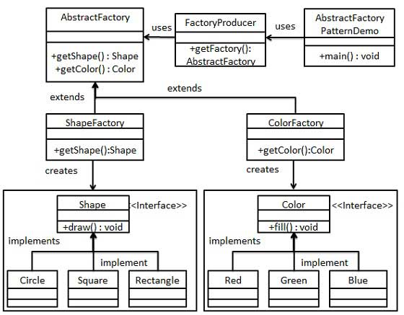

Step 1

第一步

Create an interface for Shapes.

创建一个图形接口

*Shape.java*

public interface Shape {

void draw();

}

Step 2

Create concrete classes implementing the same interface.

创建实现相同接口的具体类（Shape interface）

*Rectangle.java*

public class Rectangle implements Shape {

@Override

public void draw() {

System.out.println("Inside Rectangle::draw() method.");

}

}

*Square.java*

public class Square implements Shape {

@Override

public void draw() {

System.out.println("Inside Square::draw() method.");

}

}

*Circle.java*

public class Circle implements Shape {

@Override

public void draw() {

System.out.println("Inside Circle::draw() method.");

}

}

Step 3

Create an interface for Colors.

创建一个颜色接口。

*Color.java*

public interface Color {

void fill();

}

Step4

Create concrete classes implementing the same interface.

创建实现相同接口的具体类（Color interface）

*Red.java*

public class Red implements Color {

@Override

public void fill() {

System.out.println("Inside Red::fill() method.");

}

}

*Green.java*

public class Green implements Color {

@Override

public void fill() {

System.out.println("Inside Green::fill() method.");

}

}

*Blue.java*

public class Blue implements Color {

@Override

public void fill() {

System.out.println("Inside Blue::fill() method.");

}

}

Step 5

Create an Abstract class to get factories for Color and Shape Objects.

创建一个抽象类来获取与工厂相对应的Color和Shape对象。

*AbstractFactory.java*

public abstract class AbstractFactory {

abstract Color getColor(String color);

abstract Shape getShape(String shape) ;

}

Step 6

Create Factory classes extending AbstractFactory to generate object of concrete class based on given information.

创建多个继承AbstractFactory的工厂类根据传送的信息生成具体类的对象。

*ShapeFactory.java*

public class ShapeFactory extends AbstractFactory {

@Override

public Shape getShape(String shapeType){

if(shapeType == null){

return null;

}

if(shapeType.equalsIgnoreCase("CIRCLE")){

return new Circle();

}else if(shapeType.equalsIgnoreCase("RECTANGLE")){

return new Rectangle();

}else if(shapeType.equalsIgnoreCase("SQUARE")){

return new Square();

}

return null;

}

@Override

Color getColor(String color) {

return null;

}

}

*ColorFactory.java*

public class ColorFactory extends AbstractFactory {

@Override

public Shape getShape(String shapeType){

return null;

}

@Override

Color getColor(String color) {

if(color == null){

return null;

}

if(color.equalsIgnoreCase("RED")){

return new Red();

}else if(color.equalsIgnoreCase("GREEN")){

return new Green();

}else if(color.equalsIgnoreCase("BLUE")){

return new Blue();

}

return null;

}

}

Step 7

Create a Factory generator/producer class to get factories by passing an information such as Shape or Color

创建一个工厂生成器通过传递的Shape和Color这样的信息来生成工厂。

*FactoryProducer.java*

public class FactoryProducer {

public static AbstractFactory getFactory(String choice){

if(choice.equalsIgnoreCase("SHAPE")){

return new ShapeFactory();

}else if(choice.equalsIgnoreCase("COLOR")){

return new ColorFactory();

}

return null;

}

}

Step 8

Use the FactoryProducer to get AbstractFactory in order to get factories of concrete classes by passing an information such as type.

使用FactoryProducer来获得AbstractFactory，使它通过传递类型信息来获得具体类生产工厂。

*AbstractFactoryPatternDemo.java*

public class AbstractFactoryPatternDemo {

public static void main(String[] args) {

//get shape factory

AbstractFactory shapeFactory = FactoryProducer.getFactory("SHAPE");

//get an object of Shape Circle

Shape shape1 = shapeFactory.getShape("CIRCLE");

//call draw method of Shape Circle

shape1.draw();

//get an object of Shape Rectangle

Shape shape2 = shapeFactory.getShape("RECTANGLE");

//call draw method of Shape Rectangle

shape2.draw();

//get an object of Shape Square

Shape shape3 = shapeFactory.getShape("SQUARE");

//call draw method of Shape Square

shape3.draw();

//get color factory

AbstractFactory colorFactory = FactoryProducer.getFactory("COLOR");

//get an object of Color Red

Color color1 = colorFactory.getColor("RED");

//call fill method of Red

color1.fill();

//get an object of Color Green

Color color2 = colorFactory.getColor("Green");

//call fill method of Green

color2.fill();

//get an object of Color Blue

Color color3 = colorFactory.getColor("BLUE");

//call fill method of Color Blue

color3.fill();

}

}

Step 9

Verify the output.

校验输出。

Inside Circle::draw() method.

Inside Rectangle::draw() method.

Inside Square::draw() method.

Inside Red::fill() method.

Inside Green::fill() method.

Inside Blue::fill() method.